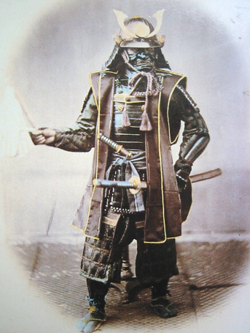  Samurai | 1._______ nobles hired by the _______ and _______.  2.Protected the ______ and were paid with _______ and ________.  3.Fought on horseback with _______, _______, and __________________.  4.Lived by a strict code of conduct known as __________. | Reflection response 1  ________________________
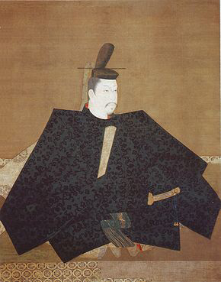  Shogun | 1.In the early ______ powerful Japanese families fought for ______ and ________ of the _________.  2._________ __________ was made the first shogun and was given control of the emperors _________.  3.Shogun ruled Japan for _____ years.  4.In the _______ Japan was divided into _____ ___________ that were controlled by the _________. | Reflection response 2  ________________________
Daimyo  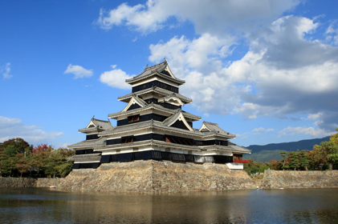 | 1.Daimyo pledged their loyalty to the __________ and the ________, but controlled their land ______________.  2.Daimyo owned _______ of the ______ producing land.  3.The daimyo hired _________ to protect their land and were given _______ in return. They received _______ land from the daimyo than from the _________.  4.The daimyo would constantly ________ each other for more __________ in the hopes of becoming a __________. | Reflection response 3  ________________________

Reflection 1 continued:____________________________________________________________
______________________________________________________________________________
______________________________________________________________________________
______________________________________________________________________________
______________________________________________________________________________
______________________________________________________________________________
______________________________________________________________________________
______________________________________________________________________________
______________________________________________________________________________
______________________________________________________________________________
______________________________________________________________________________
______________________________________________________________________________
______________________________________________________________________________
Reflection 2 continued:____________________________________________________________
______________________________________________________________________________
______________________________________________________________________________
______________________________________________________________________________
______________________________________________________________________________
______________________________________________________________________________
______________________________________________________________________________
______________________________________________________________________________
______________________________________________________________________________
______________________________________________________________________________
______________________________________________________________________________
______________________________________________________________________________
______________________________________________________________________________
Reflection 3 continued:____________________________________________________________
______________________________________________________________________________
______________________________________________________________________________
______________________________________________________________________________
______________________________________________________________________________
______________________________________________________________________________
______________________________________________________________________________
______________________________________________________________________________
______________________________________________________________________________
______________________________________________________________________________
______________________________________________________________________________
______________________________________________________________________________
______________________________________________________________________________
______________________________________________________________________________

