Appetizer  $4 summary:  Japan contains many islands and is close to China and Korea. It was ruled by clans until the Yamato clan took control and became the emperor. Prince Shotoku created a constitution and was heavily influenced by China’s government and Buddhism.  Entrée/Main Course  Section A, Travel Brochure:  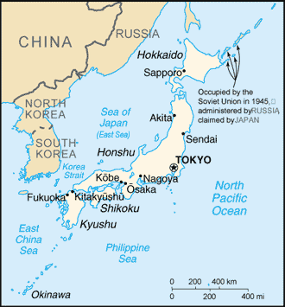  Location  - Japan is located in the Pacific Ocean, and is just West of China and Korea.  Flow of Ideas  - Due to its close proximity to China and Korea, many of their ideas had a tremendous influence on Japan and its Society. | Entrée/Main Course Continued  - Japanese officials and students were sent to learn from their governments.  - This caused the societies of China and Korea to directly impact Japanese society.  - An example of this influence is Buddhism.  - Prince Shotoku ordered Buddhist temples to be built throughout Japan.  - One of them still stands today, and Buddhism is still one of the main religions in Japan.  Section B, Acrostic Poem:  Shotoku was a Yamato prince who took  charge of Japan on behalf of his aunt.  He wanted to create a strong government  and looked to China as an example of  what to do.  One of the first things he did was create a  constitution that gave the emperor all  the power.  To further learn from China, he sent  officials and students to study the  Chinese government.  One of the most important things they  learned was Buddhist teachings, and  this had a tremendous influence on  Prince Shotoku.  Korea and China also influenced art,  medicine, and philosophy.  Under Prince Shotoku’s rule Japan’s  central government became very strong  and powerful. | Dessert  Headline Summaries:  Extra! Extra! Japan is an island nation made up of 188 volcanoes and only 20% of its land is farmable!  Breaking news! Japan’s first settlers arrived between 30,000 and 10,000 B.C.E. Around 300 B.C.E. the Yayoi came and organized themselves into Clans. The Yamato clan took over and ruled Japan at around 500 C.E. creating the line of Emperor’s that still exists today.  This just in! Prince Shotoku became the emperor of Japan around 600 C.E. He preceded to reform Japan by creating a constitution, which led to a strong central government. He was heavily influenced by Chinese and Korean forms of government and philosophies.  Read all about it! Japanese Shinto religion believes that all natural things are alive and have their own spirits. These spirits are prayed to at shrines and this religion is still practiced today!

